TourneyPredict
Platform Development Proposal

Prepared for: TourneyPredict Executive Team
Prepared by: SIP Consult
Date: December 2025
1. Executive Summary
TourneyPredict is positioned to redefine global sports engagement during major tournaments such as the 2026 FIFA World Cup, UEFA Championships, top European leagues, and the Super Bowl. The platform will offer users a low-barrier, AI-driven prediction and pool-based competition experience.
The solution combines AI-driven Smart Picks, blockchain-secured prize distribution, multilingual interfaces, global payment flexibility, customizable pools, and viral social gaming features. It is designed to scale to over 100 million users during the World Cup period.
This proposal presents the delivery scope, technical architecture, implementation approach, timelines, and cost structure for production readiness.
The recommended architecture uses Next.js on Vercel, Azure Container Apps, Azure PostgreSQL, Azure Redis, Azure AD B2C, Azure ML, Cloudflare, GitHub Actions, and Sentry. This ensures global scalability, strong performance, secure transactions, real-time updates, and operational efficiency.
The implementation schedule covers a 6-week MVP and a 6-week integration and scale-up phase to ensure launch readiness before the 2026 World Cup.
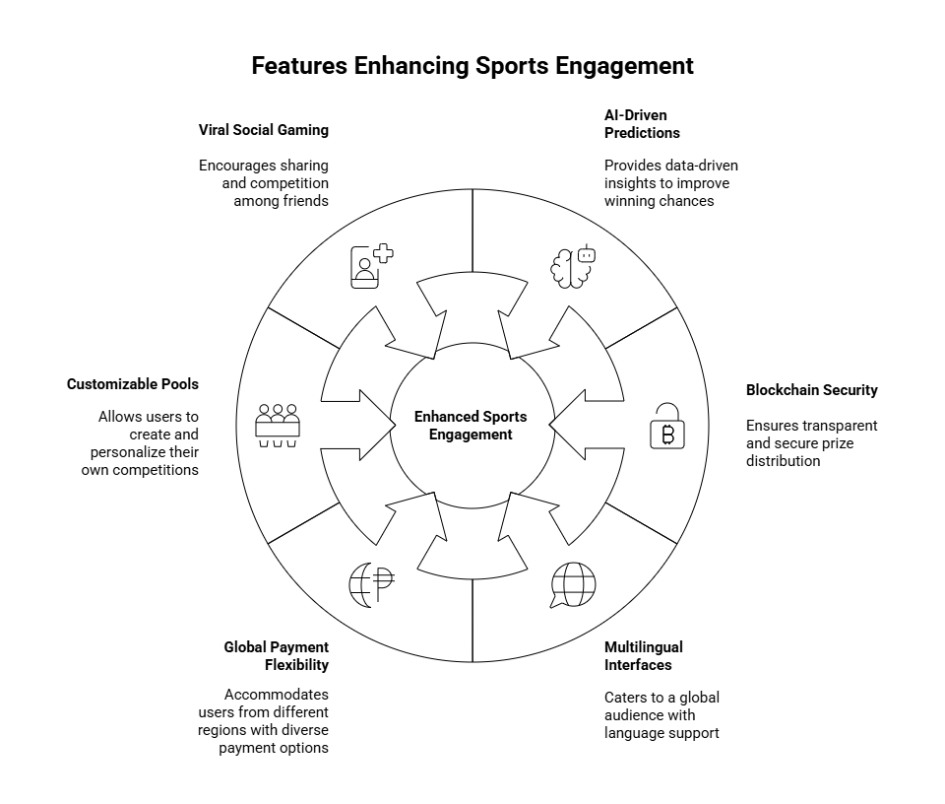
2. Scope of Work
The delivery scope encompasses the development and deployment of a fully functional and scalable TourneyPredict platform. This includes the following key components:
- Frontend Application: A user-friendly web application built with Next.js, providing a seamless and engaging experience across devices.
- Backend Services: A robust set of backend services built on Azure Container Apps, handling user authentication, data processing, and prize distribution.
- AI Prediction Engine: An AI model trained on historical sports data, providing accurate and insightful predictions.
- Blockchain Integration: Integration with a blockchain network for secure and transparent prize distribution.
- Payment Gateway Integration: Integration with multiple payment gateways to support global payment flexibility.
- Database and Storage: A scalable database solution using Azure PostgreSQL and Azure Redis for efficient data storage and retrieval.
- Infrastructure and Deployment: A fully automated infrastructure and deployment pipeline using GitHub Actions and Cloudflare.
- Monitoring and Logging: Comprehensive monitoring and logging using Sentry to ensure platform stability and performance.
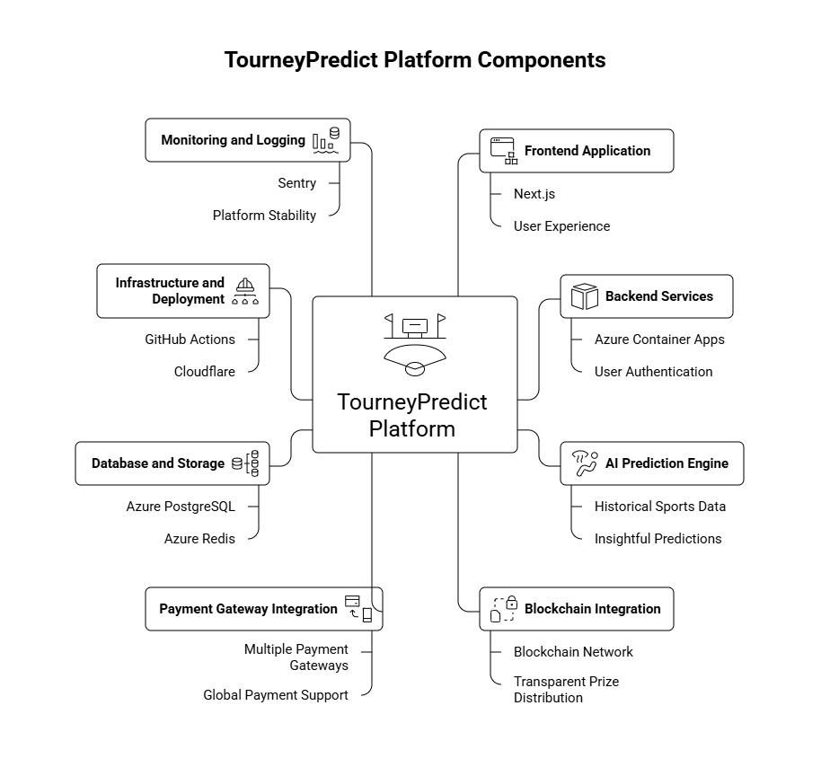
3. Approach
3.1 Delivery Methodology
A hybrid agile approach will be used to support rapid feature delivery and global deployment. Steps include:
- Discovery, user journey refinement, and architecture confirmation
- Incremental delivery in two-week sprints
- Continuous user testing with selected beta groups
- Full security, load, and usability testing
- Deployment and readiness review
3.2 Collaboration Model
- Daily standups involving both teams
- Weekly demonstration of deliverables
- Shared sprint backlog using Jira or Azure DevOps
- Dedicated communication channel on Slack or Teams

4. Technical Approach
Below is the proposed architecture designed for reliability, scalability, and real-time performance.
4.1 Frontend
Next.js hosted on Vercel
- Global CDN distribution
- Preview deployments for rapid iteration
- Strong performance for interactive dashboards
4.2 Backend
Node.js and TypeScript on Azure Container Apps
- Serverless container hosting
- Autoscaling to millions of concurrent users
- Ideal for modular microservices such as scoring, user management, payouts, AI gateway, and pool engine
4.3 Database
Azure Database for PostgreSQL Flexible Server
- High availability and automated backups
- Handles high read and write traffic
- Supports analytical queries for scoring models
4.4 Cache and Realtime
Azure Cache for Redis
- Manages leaderboards
- Tracks live game updates
- Stores sessions and throttling rules
4.5 Authentication
Azure AD B2C
- Supports SMS login, email login, and social authentication
- Includes MFA
- Scales globally and ensures secure identity management
4.6 File Storage
Azure Blob Storage with Azure CDN and Cloudflare
- Asset storage for avatars, bracket graphics, and social sharing cards
- Cloudflare shields the platform with strong DDoS protection and a Web Application Firewall
4.7 AI and Machine Learning
Azure Machine Learning
- Training Smart Picks models using Goalserve historical data
- Version management and controlled model rollouts
- Managed inference endpoints for live predictions
4.8 Blockchain
- Smart contract automation on Polygon
- Trust Wallet integration as described in the business case
- Automated payout workflows for winners
4.9 CI and CD
GitHub Actions
- Automated testing
- Build and deploy pipelines for all environments
- Secrets managed through Azure Key Vault
4.10 Monitoring and Metrics
- Sentry for client side error tracking
- Application Insights for backend metrics and alerting
- Log pipelines for auditing and fraud prevention
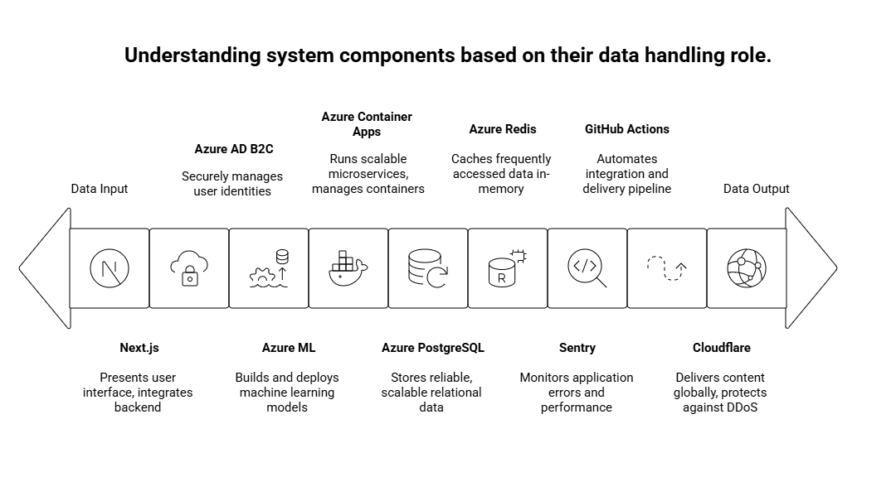
5. Delivery Timeline
Phase 1: MVP (6 Weeks)
Week | Deliverables
1 | Architecture validation, UI wireframes, environment setup
2 | Authentication, registration, and profile setup
3 | Bracket engine, scoring engine, pool management
4 | AI Smart Picks version 1 and Goalserve integration
5 | Blockchain testnet flow and admin console
6 | QA, bug fixing, staging deployment
Phase 2: Integrations and Scaling (8 Weeks)
Week | Deliverables
7 to 8 | Azure ML pipelines and Smart Picks version 2
9 to 10 | Blockchain production contracts and payout automation
11 | Mobile app wrappers for Android and iOS
12-13 | Observability setup and load testing
14 | Production deployment and go-live preparation
Total Implementation Duration: 14 Weeks

6. Cost Estimate
A blended rate of USD 450 per day will apply to the project team.
Team Composition
- 1 Software Architect
- 1 UX Expert
- 2 Software Engineers
- 1 QA Expert
Cost Summary
Phase | Duration | Team Days | Rate | Total Cost
MVP | 6 weeks | 30 workdays | 450 | USD 13,500
Integrations and Scale-up | 8 weeks | 40 workdays | 450 | USD 18,000
Total Estimated Cost
USD 31,500
Cloud hosting, Goalserve subscription, blockchain gas fees, and app store fees are not included.
Additionally, SLA fees not included.
Conclusion
TourneyPredict is a globally relevant digital product that combines AI, blockchain, sports entertainment, and social competition. The recommended architecture and delivery approach provide the right balance of rapid market readiness and robust scalability.
With this plan, TourneyPredict will be ready for global activation during the 2026 FIFA World Cup and will have the technical and operational foundation to sustain long-term growth across multiple tournaments.

